DRAFT RESOLUTIONS OF EXTRAORDINARY GENERAL MEETING OF
MEDICALGORITHMICS S.A., REGISTERED OFFICE IN WARSAW,
CONVENED ON OCTOBER 28, 2022

Resolution 1/10/2022
October 28, 2022
Extraordinary General Meeting of
Medicalgorithmics S.A., registered office in Warsaw
Election of General Meeting Chairperson

Article 1

The Extraordinary General Meeting of Medicalgorithmics S.A. hereby elects Mr/Ms ____________________ as the Chairperson of the General Meeting.

Article 2
This resolution becomes effective once adopted.

Explanation:
The resolution is purely administrative.

Resolution 2/10/2022
October 28, 2022
Extraordinary General Meeting of
Medicalgorithmics S.A., registered office in Warsaw
Adoption of General Meeting agenda

Article 1

The Extraordinary General Meeting of Medicalgorithmics S.A. hereby adopts the following agenda of this session:
- Opening of the General Meeting;
- Election of the General Meeting Chairperson;
- Acknowledgement of proper summons to the General Meeting and its capacity to adopt resolutions;
- Adoption of the General Meeting agenda;
- Adoption of a resolution concerning: cancellation of Resolution 32/06/2022 of the Annual General Meeting of Medicalgorithmics S.A. dated June 30, 2022.
- Adoption of a resolution concerning: increase of the Company's share capital through issue of series I, J, K and L shares, waiver of existing shareholders’ subscription rights, and private subscription offer for a designated entity, as well as change of Article 5 (1) and (2) of the Articles of Association;
- Adoption of a resolution concerning: changes of the Articles of Association;
- Adoption of a resolution concerning: adoption of the restated version of the Articles of Association;
- Adoption of a resolution concerning: determination of the number of Supervisory Board members;
- Adoption of a resolution concerning: appointment of a member of the Supervisory Board
- Adoption of a resolution concerning: election of the Chairperson of the Supervisory Board;
- Closing of the General Meeting.
Article 2
This resolution becomes effective once adopted.

Explanation:
The resolution is purely administrative.

Resolution 3/10/2022
October 28, 2022
Extraordinary General Meeting of
Medicalgorithmics S.A., registered office in Warsaw
on cancellation of Resolution 32/06/2022 of the Annual General Meeting of Medicalgorithmics S.A. dated June 30, 2022.

Article 1

The Extraordinary General Meeting of Medicalgorithmics S.A. hereby cancels Resolution 32/06/2022 of the Annual General Meeting of Medicalgorithmics S.A., dated June 30, 2022.

Article 2
This resolution becomes effective once adopted.

Explanation:
In view of the decision of the Management Board to refrain from implementing Resolution 32/06/2022 of the Annual General Meeting of Medicalgorithmics S.A. dated June 30, 2022, that resolution should be cancelled.

Resolution 4/10/2022
October 28, 2022
Extraordinary General Meeting of
Medicalgorithmics S.A., registered office in Warsaw
Increase of the Company's share capital through issue of series I, J, K and L shares; waiver of existing shareholders’ subscription rights; and private subscription offer for a designated entity; as well as change of Article 5 (1) and (2) of the Articles of Association

Article 1

Acting based on Articles 431, 1 § 2.1, 432 § 1 and Article 433 § 2 of the Polish Commercial Companies Code of September 15, 2000 (“Code"), as well as Article 14 of the Articles of Association, the Extraordinary General Meeting hereby resolves as follows:

Article 2.
- The Extraordinary General Meeting of the Company increases the Company's share capital by PLN 497,638.40 (four hundred and ninety-seven thousand six hundred and thirty-eight zlotys and 40/100), i.e. from PLN 497,638.50 (four hundred and ninety-seven thousand six hundred and thirty-eight zlotys and 50/100) to PLN 995,276.90 (nine hundred and ninety-five thousand two hundred and seventy-six zlotys and 90/100).
- The share capital will be increased through issue of:
- 995,276 series I bearer shares, which are ordinary shares with a par value of PLN 0.10 (10/100) per share, for a total nominal value of PLN 99,527.60 (ninety-nine thousand five hundred and twenty-seven zlotys and 60/100) ("Series I Shares");
- 1,194,331 series J registered shares, which are ordinary shares with a par value of PLN 0.10 (10/100) per share, for a total nominal value of PLN 119,433.10 (one hundred and nineteen thousand four hundred and thirty-three zlotys and 10/100) ("Series J Shares");
- 1,433,197 registered series K shares, which are ordinary shares with a par value of PLN 0.10 (10/100) per share, for a total nominal value of PLN 143,319.70 (one hundred and forty-three thousand three hundred and nineteen zlotys and 70/100) ("Series K Shares");
- 1,353,580 series L registered shares, which are ordinary shares with a par value of PLN 0.10 (10/100) per share, for a total nominal value of PLN 135,358.00 (one hundred and thirty-five thousand three hundred and fifty-eight zlotys) ("Series L Shares")
(Series I Shares, Series J Shares, Series K Shares and Series L Shares are hereinafter collectively referred to as "Offered Shares").
- The Issue of the Offered Shares will take place by private subscription as referred to in Article 431 § 2(1) of the Code, to be conducted by way of a private subscription, and the Management Board will offer:
- 995,276 Series I Shares for subscription by Biofund Capital Management LLC, based in Miami, FL, address: 3608 Stewart Ave, Suite 100, Miami, FL ("Biofund");
- 1,194,331 Series J Shares for subscription by Biofund;
- 1,433,197 Series K Shares for subscription by Biofund;
- 1,353,580 Series L Shares for subscription by Biofund.
The Company will execute a subscription agreement concerning the Offered Shares, based on the procedure of Article 431 § 2.1 of the Code, through a private subscription, by December 31, 2022.
- The issue price of Series I Shares will be PLN 44.27 (forty-four zlotys and 27/100) for each individual Series I Share, with the total issue price PLN 44,060,868.52 (forty-four million sixty thousand eight hundred sixty-eight zlotys and 52/100).
- The issue price of Series J Shares will be PLN 44.27 (forty-four zlotys and 27/100) for each individual Series J Share, with the total issue price PLN 52,873,033.37 (fifty-two million eight hundred seventy-three thousand thirty-three zlotys and 37/100).
- The issue price of Series K Shares will be PLN 44.27 (forty-four zlotys and 27/100) for each individual Series K Share, with the total issue price PLN 63,447,631.19 (sixty-three million four hundred and forty-seven thousand six hundred and thirty-one zlotys and 19/100).
- The issue price of Series L Shares will be PLN 44.27 (forty-four zlotys and 27/100) for each individual Series L Share, with the total issue price PLN 59,922,986.60 (fifty-nine million nine hundred twenty-two thousand nine hundred eighty-six zlotys and 60/100).
- The Extraordinary General Meeting hereby authorizes the Management Board to take any and all actions related to the share capital increase and the issue of the Offered Shares, in particular: to determine the terms of the private subscription of the Offered Shares (according to Article 431 § 2.1 of the Code), to offer the Offered Shares, and to execute Offered Shares subscription agreements.
- The Offered Shares will participate in dividends based on the following principles:
- if the Offered Shares are deposited in the securities account by the dividend date, established in the general meeting resolution on profit distribution, they will participate in dividends starting from the profit for the previous financial year, namely from January 1 of the financial year immediately preceding the year in which the shares were deposited in the securities account,
- if the Offered Shares are deposited in the securities account after the dividend date, established in the general meeting resolution on profit distribution, they will participate in dividends starting from the profit for a financial year in which the shares become deposited in the securities account, namely from January 1 of that financial year.
- The Management Board will offer Biofund the subscription of:
- 932,897 Series I Shares in exchange for an in-kind contribution of 300 (three hundred) shares of Kardiolytics Inc. based in Oklahoma, adress: 296 Woodward Blvd. Tulsa, Oklahoma, 74114, ("Kardiolytics") (hereinafter "KL Shares");
- 62,379 Series I Shares in exchange for a cash contribution of PLN 2,761,526.64 (two million seven hundred and sixty-one thousand five hundred and twenty-six zlotys and 64/100);
- 1,119,476 Series J Shares in exchange for an in-kind contribution of 360 (three hundred and sixty) KL Shares;
- 74,855 Series J Shares in exchange for a cash contribution of PLN 3,313,823.11 (three million three hundred and thirteen thousand eight hundred and twenty-three zlotys and 11/100);
- 1,343,371 Series K Shares in exchange for an in-kind contribution of 432 (four hundred and thirty-two) KL Shares;
- 89,826 Series K Shares in exchange for a cash contribution of PLN 3,976,578.88 (three million nine hundred and seventy-six thousand five hundred and seventy-eight zlotys and 88/100);
- 1,268,740 Series L Shares in exchange for an in kind contribution of 408 KL Shares;
- 84,840 Series L Shares in exchange for a cash contribution of PLN 3,755,881.65 (three million seven hundred and fifty-five thousand eight hundred and eighty-one zlotys and 65/100).

Article 2.
- Having read the written opinion of the Management Board which explains the reasons behind the waive of the existing shareholders’ subscription rights to the Offered Shares as well as the proposed principles for determining the issue price of the Offered Shares, acting in the interest of the Company the Extraordinary General Meeting hereby waives the subscription rights of the Company’s existing shareholders to the Offered Shares.
- The opinion of the Management Board referred to in section 1, which explains the full waiver of existing shareholders’ subscription rights to the Offered Shares, is enclosed to this resolution.

Article 3.
- The Offered Shares will be applied for in order to admit and introduce them to trading on the regulated market of the Warsaw Stock Exchange (Giełda Papierów Wartościowych w Warszawie S.A.), without drafting or publication of an issue prospectus according to Article 1.5.(a) of Regulation 2017/1129. The Management Board is hereby obligated and authorized to take any and all actions as may be necessary in connection with the admission and the introduction of the Shares to trading on the regulated market of the Warsaw Stock Exchange in accordance with this resolution.
- The Offered Shares will be dematerialized as referred to in the Financial Instruments Trading Act of July 29, 2005. The Management Board is hereby authorized to conclude with the Central Securities Depository of Poland (Krajowy Depozyt Papierów Wartościowych S.A.) an agreement to register the Offered Shares and to perform any other actions as may be necessary towards their dematerialization.
- The clauses of Article 3 apply as long as there are any shares of the Company admitted to trading on a regulated market operated by the Warsaw Stock Exchange.

Article 4.
In connection with the share capital increase referred to in Article 1 of this resolution, the Extraordinary General Meeting resolves to amend Article 5, Sections 1 and 2 of the Articles of Association which will read as follows: “
- The share capital of the Company is PLN 995,276.90 (nine hundred and ninety-five thousand two hundred and seventy-six zlotys and 90/100).
- The share capital consists of 9,952,769 (nine million nine hundred fifty-two thousand seven hundred sixty-nine ordinary shares with par value of PLN 0.10 (10/100) each, including:
- 1,747,200 (one million seven hundred and forty-seven thousand two hundred) series A bearer shares,
- 508,200 (five hundred and eight thousand two hundred) series B bearer shares;
- 236,926 (two hundred and thirty-six thousand nine hundred and twenty-six) series C bearer shares;
- 929,600 (nine hundred and twenty-nine thousand six hundred) series D bearer shares;
- 33,600 (thirty-three thousand six hundred) series E bearer shares;
- 151,000 (one hundred and fifty-one thousand) series F bearer shares;
- 721,303 (seven hundred and twenty-one thousand three hundred and three) series G bearer shares;
- 648,556 (six hundred and forty-eight thousand five hundred and fifty-six) series H bearer shares,
- 995,276 (nine hundred and ninety-five thousand two hundred and sixty) series I bearer shares,
- 1,194,331 (one million one hundred and ninety-four thousand three hundred and thirty-one) Series J registered shares;
- 1,433,197 (one million four hundred and thirty-three thousand one hundred and ninety-seven) Series K registered shares;
- 1,353,580 (one million three hundred and fifty-three thousand five hundred and eighty) Series L registered shares.”

Article 5.
This resolution becomes effective once adopted, however the share capital increase will have legal effect upon disclosure of the change by the relevant registry.

Appendix 1 to Resolution 4/10/2022 of General Meeting – Management Board opinion explaining the full waiver of existing shareholders’ subscription rights to the Offered Shares.

Warsaw, October 1, 2022
Opinion of Management Board
Medicalgorithmics S.A. based in Warsaw
Explanation of full waiver of the existing shareholders’ subscription rights to the new shares, series I, J, K and L

This opinion (“Opinion”) has been adopted by the Management Board of Medicalgorithmics S.A., registered office in Warsaw, Al. Jerozolimskie 81, Polish tax number [NIP]: 5213361457, statistical number [REGON]: 140186973, entered into the commercial register of the National Court Register, District Court for Warsaw, 12th Commercial Division, with company number [KRS]: 0000372848 (“Company”), pursuant to Article 433 § 2 of the Commercial Companies Code of September 15, 2000 (Polish Official Journal: Dz.U. 2022.1467, hereinafter “Code”), in connection with the planned adoption by the Extraordinary General Meeting of a resolution on: increase of the Company's share capital through issue of series I, J, K and L shares, waiver of existing shareholders’ subscription rights, private subscription offer for a designated entity, and changes of the Articles of Association.

The Company's share capital will be increased from PLN 497,638.50 (four hundred and ninety-seven thousand six hundred and thirty-eight zlotys and 50/100) to PLN 995,276.90 (nine hundred and ninety-five thousand two hundred and seventy-six zlotys and 90/100), namely by PLN 497,638.40 (four hundred and ninety-seven thousand six hundred and thirty-eight zlotys and 40/100) (“Share Capital Increase”), by issue of:

- 995,276 (nine hundred and ninety-five thousand two hundred and seventy-six) series I bearer shares, which are ordinary shares with a par value of PLN 0.10 (10/100) per share, for the issue price of 1 (one) share PLN 44.27 (forty-four zlotys and 27/100) and the total issue price of PLN 44,060,868.52 (forty-four million sixty thousand eight hundred sixty-eight zlotys and 52/100) (“Series I Shares”);
- 1,194,331 (one million one hundred and ninety-four thousand three hundred and thirty-one) series J registered shares, which are ordinary shares with a par value of PLN 0.10 (10/100) per share, for an issue price of 1 (one) share of PLN 44.27 (forty-four zlotys and 27/100) and the total issue price of PLN 52,873,033.37 (fifty-two million eight hundred and seventy-three thousand thirty-three zlotys and 37/100) (“Series J Shares”);
- 1,433,197 (one million four hundred and thirty-three thousand one hundred and ninety-seven) registered series K shares, which are ordinary shares with a par value of PLN 0.10 (10/100) per share, for an issue price of 1 (one) share of PLN 44.27 (forty-four zlotys and 27/100) and the total issue price of PLN 63,447,631.19 (sixty-three million four hundred forty-seven thousand six hundred thirty-one zlotys and 19/100) (“Series K Shares”);
- 1,353,580 (one million three hundred and fifty-three thousand five hundred and eighty) series L registered shares, which are ordinary shares with a par value of PLN 0.10 (10/100) per share, for an issue price of 1 (one) share of PLN 44.27 (forty-four zlotys and 27/100) and the total issue price of PLN 59,922,986.60 (fifty-nine million nine hundred and twenty-two thousand nine hundred and eighty-six zlotys and 60/100) (“Series L Shares”)

(Series I Shares, Series J Shares, Series K Shares and Series L Shares hereinafter “Offered Shares”). The issue of the Investor’s Offered Shares will take place by private subscription as referred to in Article 431 § 2(1) of the Code, to be conducted by way of a private offer.

The Management Board will offer the Investor’s Shares to Biofund Capital Management LLC based in Miami, FL, address: 3608 Stewart Ave, Suite 100, Miami, FL (“Investor”), which will subscribe for:
- 100% of the Series I Shares, with the issue price of PLN 44,060,868.52 (forty-four million sixty thousand eight hundred sixty-eight zlotys and 52/100) to be paid as follows:
  - partly by a cash contribution of PLN 2,761,526.64 (two million seven hundred sixty-one thousand five hundred twenty-six and 64/100) ("Cash Contribution 1"); and
  - partly by an in-kind contribution of 300 (three hundred) shares in Kardiolytics Inc. based in Oklahoma, adress: 296 Woodward Blvd. Tulsa, Oklahoma, 74114, a company registered in the trade register of the State of Delaware, company number 7063366 (“Contributed Company"), representing 20% of the share capital of the Contributed Company and entitling to 20% of votes at the general meeting of the Contributed Company (“Contributed Shares 1");
- 100% of the Series I Shares, with the issue price of PLN 52,873,033.37 (forty-four million sixty thousand eight hundred sixty-eight zlotys and 37/100) to be paid as follows:
  - partly by a cash contribution of PLN 3,313,823.11 (three million three hundred and thirteen thousand eight hundred and twenty-three zlotys and 11/100) ("Cash Contribution 2"); and
  - partly by an in-kind contribution of 360 (three hundred and sixty) shares in the Contributed Company, representing 24% of the Contributed Company's share capital and entitling to 24% of votes at its general meeting (“Contributed Shares 2");
- 100% of the Series K Shares, with the issue price of PLN 63,447,631.19 (sixty-three million four hundred and forty-seven thousand six hundred and thirty-one zlotys and 19/100) to be paid as follows:
- partly by a cash contribution in the amount of PLN 3,976,578.88 (three million nine hundred seventy-six thousand five hundred seventy-eight and 88/100) ("Cash Contribution 3"); and
- partly by an in-kind contribution of 432 (four hundred and thirty-two) shares in the Contributed Company, representing 28.80% of the Contributed Company's share capital and entitling to 28.80% of votes at its general meeting (“Contributed Shares 3");
- 100% of the Series L Shares, with the issue price of PLN 59,922,986.60 (fifty-nine million nine hundred twenty-two thousand nine hundred eighty-six zlotys and 60/100) to be paid as follows:
- partly by a cash contribution of PLN 3,755,881.65 (three million seven hundred and fifty-five thousand eight hundred and eighty-one zlotys and 65/100) ("Cash Contribution 4"); and
- partly by an in-kind contribution of 408 (four hundred and eight) shares in the Contributed Company, representing 27.20% of its share capital and entitling to 27.20% of votes at its general meeting (“Contributed Shares 4”);

(Contributed Shares 1, Contributed Shares 2, Contributed Shares 3 and Contributed Shares 4 hereinafter "Contributed Shares").

The Contributed Shares were examined in an auditor opinion (as referred to in the Code),dated September 27, 2022, in which Mr Krzysztof Horodko, the certified auditor (auditor license: 10229), acting in the name of TPA sp. z o.o. sp.k., a limited partnership based in Warsaw, issued an auditor opinion on the fair value of non-cash contributions (namely, the Contributed Shares of USD 44,890,589), according to which the used valuation of the Contributed Shares in the amount of PLN 206,496,709.40 (based on the USD/PLN exchange rate of 1.00/4.60) is, in the opinion of the Management Board, a fair valuation ("Auditor Opinion"). The Auditor's Opinion is enclosed as Exhibit 1 to this Opinion.

The issue of Investor’s Shares to the Investor will be associated with another transaction involving the acquisition by the Investor of a share package which will entitle the Investor to a total of 49.99% shares in the Company and 49.99% votes at its General Meeting. The issue of the Investor’s Shares will bring benefits to both the Company and the Investor through the added value generated thanks to synergies that arise between the businesses of the Contributed Company and of the Company, further enabling the optimization of processes in both. Thanks to the artificial intelligence-based technology being developed by the Contributed Company, the Company will gain the opportunity to expand the range of services already provided, develop them further based on new technology and gain access to new customer base, which should lead to further growth of the Company.

In addition, the funding obtained from the Share Capital Increase will allow the Company to capitalize its operations and further develop them as well as to achieve its development strategy goals.

If necessary to offer the Investor's Shares through an offer addressed to the existing shareholders eligible under their existing subscription rights, the time needed to raise funding that will cover Investor's Shares will be extended, while the Company's investment objectives need to be achieved in a shorter timeframe than the time limit stipulated in the Code in case of exercising such subscription rights. Other than reducing the shareholding interest in the Company of the existing shareholders, the waiver of their subscription rights will not adversely affect their rights.

In view of the above, the right conclusion is that by addressing the issue of the Investor’s Shares exclusively to an entity that is not an existing shareholder of the Company justifies the full waiver of the subscription rights held by the existing shareholders. This is a necessary step to cause all of the Investor’s Shares to be acquired by such new shareholder, which will provide the Company with the opportunity to expand its business through the acquisition of the Contributed Shares, as well as increase the value of the Company's existing shares, and last but not least promote the long-term interests of its shareholders. At the same time, the Management Board hereby declares that in all activities associated with the Share Capital Increase and the issue of the Investor’s Shares it will observe the interests of the Company and ensure that entire procedure is be carried out on arm’s length terms. Having regard to the above, the Management Board is of such opinion that the objective and the character of the Share Capital Increase justify the full waiver of the shareholders’ subscription rights with regard to the Investor’s Shares.

The issue price of Series I Shares is PLN 44.27 (forty-four zlotys and 27/100) per share. This price is a fair value and reflects the current valuation of the Company itself.

The issue price of Series J Shares is PLN 44.27 (forty-four zlotys and 27/100) per share. This price is a fair value and reflects the current valuation of the Company itself.

The issue price of Series K Shares is PLN 44.27 (forty-four zlotys and 27/100) per share. This price is a fair value and reflects the current valuation of the Company itself.

The issue price of Series L Shares is PLN 44.27 (forty-four zlotys and 27/100) per share. This price is a fair value and reflects the current valuation of the Company itself.

The proposed issue price of Series I Shares, Series J Shares, Series K Shares and Series L Shares was determined based on negotiations with the Investor as well as taking into account the Auditor Opinion.

All in all, the Management Board hereby affirmatively evaluates the draft resolution on the share capital increase through the issue of Series I Shares, Series J Shares, Series K Shares and Series L Shares, through a private subscription, with the waiver of the existing shareholders’ subscription rights, and on change of the Articles of Association, therefore recommending the shareholders to vote in favor of that resolution.

MANAGEMENT BOARD:

________________________________
Maciej Gamrot - Member of Management Board, CFO
________________________________
Jaroslaw Jerzakowski- Member of Management Board

Exhibit 1
AUDITOR OPINION

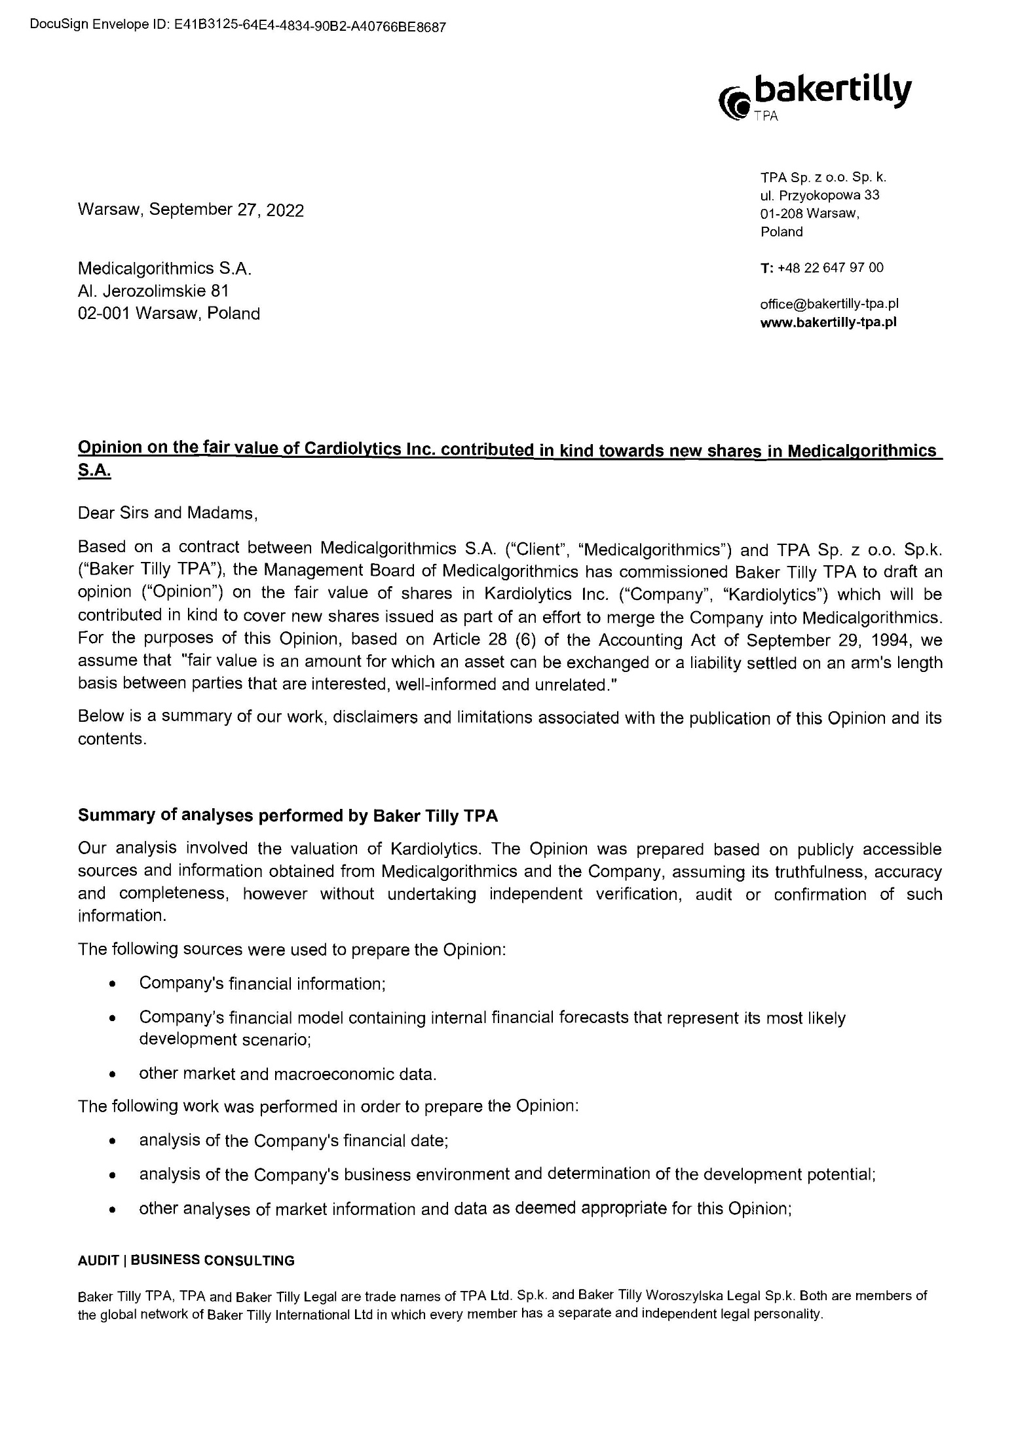
Exhibit 1
AUDITOR OPINION
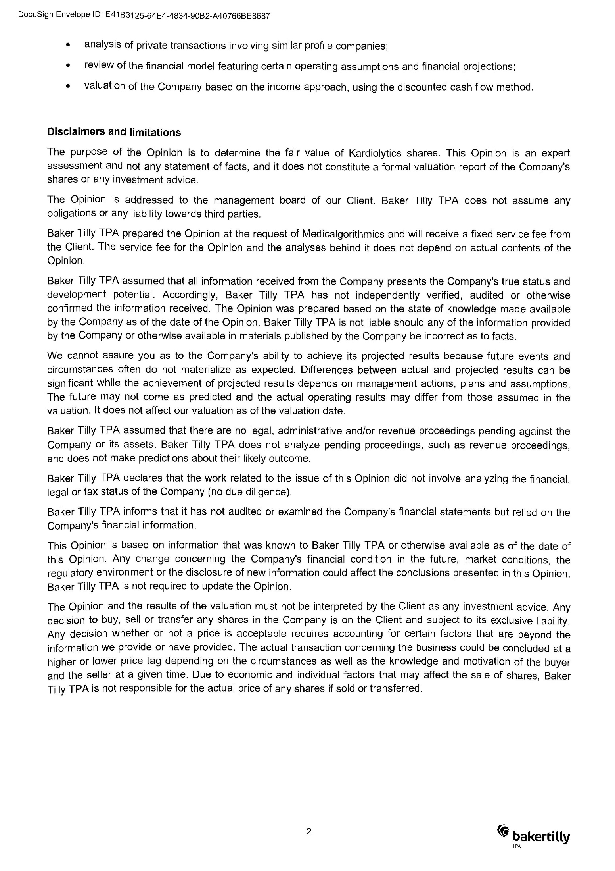
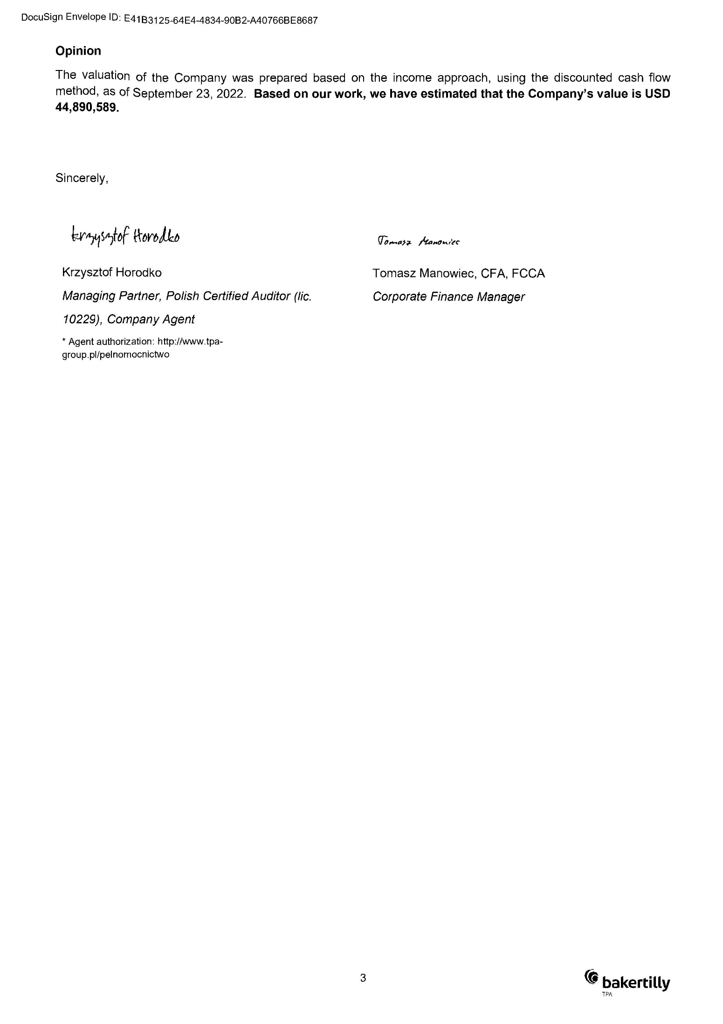

Explanation:
The issue of shares addressed to Biofund Capital Management LLC ("Investor") is associated with an investment agreement between Medicalgorithmics S.A. (“Company”) and Biofund (“Investment Agreement”) which stipulates the acquisition by the Investor of a share package entitling the Investor to a total of 49.99% shares in the Company and 49.99% votes at its General Meeting.

The issue of the shares will bring benefits to both the Company and the Investor through the added value generated thanks to synergies that arise between the businesses of Kardiolytics (“Contributed Company”) and of the Company, further enabling the optimization of processes in both. Thanks to the artificial intelligence-based technology being developed by the Contributed Company, the Company will gain the opportunity to expand the range of services already provided, develop them further based on new technology and gain access to new customer base, which should lead to further growth of the Company.

Resolution 5/10/2022
October 28, 2022
Extraordinary General Meeting of
Medicalgorithmics S.A., registered office in Warsaw
Change of the Articles of Association

Article 1.

Pursuant to Article 430 § 1 of the Commercial Companies Code, the General Meeting resolves to amend the Articles of Association as follows:

- Article 5 section of the Articles of Association which currently reads:

“4. The Company may issue registered or bearer shares.”

is hereby changed to read as follows:

“4. The Company may issue registered or bearer shares. The Management Board of is authorized to change the type of J, K and L series shares from registered shares to bearer’s shares in line with the general regulations of law."

2. Article 9 of the Articles of Association is hereby cancelled in full.

3. To add a new point in Article 20, namely 10a which will read as follows:
"10a) consenting for the Company to enter into an agreement, another transaction or a series of related agreements or other transactions not provided for in the Company's budget, for a total value exceeding PLN 2,000,000;"

4. Article 20 section 15 of the Articles of Association which currently reads:
„15) to grant consent to:
a) subscription, acquisition of shares or joining a partnership or participating in other entities by the Company or a company from its capital group (as referred to in international accounting standards adopted in accordance with Regulation (EC) No. 1606/2002 of the European Parliament and of the Council of July 19, 2002 on the application of international accounting standards) ("Group Company"),
b) alienation or transfer of ownership of shares or joining a partnership or participating in other entities by the Company or a Group Company,
c) purchase or sell non-current assets by the Company or a Group Company for a total value exceeding PLN 5 million, however subject to item (d),
purchase investment-grade financial assets by the Company or a Group Company, excluding securities underwritten by the State,
e) contracting by the Company or a Group Company of loans or credit facilities that have not been provided for in the approved annual budget, and issue suretyship instruments or guarantees of the Company for a total value exceeding PLN 5 million,
f) issue of convertible bonds and bonds with priority rights by the Company or a Group Company,
g) alienation of the business of the Company or a Group Company, or a standalone organized part thereof,
h) payment of dividend advances by the Company,
i) appoint a company agent to represent the Company,
j) conclude an agreement with an issue underwriter (the agreement referred to in Article 433.5 of the Commercial Companies Code)."

is hereby changed to read as follows:
"15) consenting for the Management Board to:
a) subscribe for or acquire shares in another company or join a partnership or otherwise participate in other entities, by the Company or a company from its capital group (as referred to in international accounting standards adopted in accordance with Regulation (EC) No. 1606/2002 of the European Parliament and of the Council of July 19, 2002 on the application of international accounting standards) ("Group Company"),,
b) transfer or encumber shares in another company,
c) purchase or sell non-current assets by the Company or a Group Company for a total value exceeding 3% of the total non-current assets of the Company, however subject to item (d),
purchase investment-grade financial assets by the Company or a Group Company, excluding securities underwritten by the State,
e) contract loans or credit facilities that have not been provided for in the annual budget, and issue suretyship instruments or guarantees of the Company for a total value exceeding 3% of the total assets of the Company, by the Company or a Group Company,
f) pay out dividend advances,
g) appoint a company agent,
h) conclude an agreement with an issue underwriter (the agreement referred to in Article 433.5 of the Commercial Companies Code),
i) issue convertible bonds or bonds with preference rights, by the Company or a Group Company,
j) transfer the business of the Company or a Group Company, or a standalone organized part thereof,
k) transfer, encumber (including to issue licenses with sub-licensing rights) or grant an exclusive license to any intellectual or industrial property rights, whether registrable or not, which the Company is authorized to use, excluding licenses granted to distributors of the Company's products and services under distribution agreements entered into by the Company in the ordinary course of its business, however including in every case licenses that grant sublicensing rights to the licensee subject to the approval of the Management Board to be granted according to this section.

Article 2.
This resolution becomes effective once adopted, however the changed Articles of Association will have legal effect upon disclosure of the change by the relevant registry.

Explanation:
The above proposed changes to the Articles of Association are a result of the Investment Agreement made by and between the Company and the Investor.

Resolution 6/10/2022
October 28, 2022
Extraordinary General Meeting of
Medicalgorithmics S.A., registered office in Warsaw
Adoption of the restated version of the Articles of Association

Article 1.

In connection with the change of the Articles of Association introduced by the Extraordinary General Meeting by Resolution No. 4/10/2022, the Extraordinary General Meeting adopts the restated version of Articles of Association as follows:

“RESTATED ARTICLES OF ASSOCIATION of MEDICALGORITHMICS S.A.

I. GENERAL

Article 1
The business name of the Company is: Medicalgorithmics Spółka Akcyjna. The Company may use an abbreviated name: Medicalgorithmics S.A.

Article 2
The Company’s registered office is the city of Warsaw, Poland.

§ 3
- The business object of the Company's operations is (according to the Polish classification PKD 2007):
  - 26.20.Z Manufacture of computers and peripheral devices;
  - 26.30.Z Manufacture of telecommunications equipment;
  - 26.51.Z Manufacture of instruments and instruments for measurement, control and navigation;
  - 26.60.Z Manufacture of irradiation, electromedical and electrotherapeutic equipment;
  - 26.70.Z Manufacture of optical instruments and photographic equipment;
  - 27.90.Z Manufacture of other electrical equipment;
  - 32.50.Z Manufacture of medical, including dental, equipment, instruments and devices;
  - 33.13.Z Repair and maintenance of electronic and optical equipment;
  - 33.14.Z Repair of electrical equipment;
  - 33.20.Z Installation of industrial machinery and equipment;
  - 46.51.Z Wholesale of computers, computer peripheral equipment and software;
  - 46.52.ZWholesale of electronic and telecommunications equipment and parts;
  - 46.90.Z Non-specialized wholesale trade
  - 47.74.Z Retail sale of medical and orthopedic goods in specialized stores;
  - 58.29.Z Other software publishing;
  - 61.10.Z Wired telecommunications activities;
  - 61.20.Z Wireless telecommunications activities, excluding satellite telecommunications;
  - 61.90.Z Other telecommunications activities;
  - 62.01.Z Software activities;
  - 62.02.Z Computer consulting activities;
  - 62.03.Z Computer facilities management activities;
  - 62.09.Z Other information technology and computer service activities;
  - 63.11.Z Data processing, hosting and related activities;
  - 63.12.Z Web portal activities;
  - 63.99.Z Other information service activities, not elsewhere classified;
  - 64.99.Z Other financial service activities, not classified elsewhere, except insurance and pension funding;
  - 66.19.Z Other activities auxiliary to financial services, except insurance and pension funding;
  - 71.20.B Technical testing and analysis;
  - 72.11.Z Research and experimental development on biotechnology;
  - 72.19.Z Other research and experimental development on natural sciences and engineering;
  - 74.90.Z Other professional, scientific and technical activities, not elsewhere classified;
  - 77.33.Z Rental and leasing of office machinery and equipment (including computers);
  - 77.39.Z Rental and leasing of other machinery, equipment and tangible goods not elsewhere classified;
  - 77.40.Z Leasing of intellectual property and similar products, except copyrighted works;
  - 82.20.Z Call center activities;
  - 82.30.ZOrganization of conventions and trade shows;
  - 96.09.Z Other service activity not elsewhere classified;
  - 86.10.Z Hospital activities;
  - 86.2 Medical practice activities;
  - 86.21.Z General medical practice activities;
  - 86.22.Z Specialist medical practice activities;
  - 86.90.A Physiotherapy activities;
  - 86.90.C Nurse and midwife practice activities;
  - 86.90.D Paramedic activities;
  - 86.90.E Other healthcare activities not elsewhere classified.
- The Company can operate own industrial, service and retail establishments, establish companies of any business profile, as well as acquire and hold shares in other companies, both in Poland and abroad.
- The Company can issue debt securities, including convertible bonds.

Article 4
The Company has been established for an unlimited time.

II. SHARE CAPITAL AND TYPES OF SHARES

Article 5
- The share capital of the Company is PLN 995,276.90 (nine hundred and ninety-five thousand two hundred and seventy-six zlotys and 90/100).
- The share capital consists of 9,952,769 (nine million nine hundred fifty-two thousand seven hundred sixty-nine ordinary shares with par value of PLN 0.10 (10/100) each, including:
a) 1,747,200 (one million seven hundred and forty-seven thousand two hundred) series A bearer shares,
b) 508,200 (five hundred and eight thousand two hundred) series B shares;
c) 236,926 (two hundred and thirty-six thousand nine hundred and twenty-six) series C shares;
d) 929,600 (nine hundred and twenty-nine thousand six hundred) series D bearer shares;
e) 33,600 (thirty-three thousand six hundred) series E bearer shares;
f) 151,000 (one hundred and fifty-one thousand) series F bearer shares;
g) 721,303 (seven hundred and twenty-one thousand three hundred and three) series G bearer shares;
h) 648,556 (six hundred and forty-eight thousand five hundred and fifty-six) series H bearer shares,
i) 995,276 (nine hundred and ninety-five thousand two hundred and seventy) series I bearer shares,
j) 1,194,331 (one million one hundred and ninety-four thousand three hundred and thirty-one) Series J registered shares;
k) 1,433,197 (one million four hundred and thirty-three thousand one hundred and ninety-seven) Series K registered shares;
l) 1,353,580 (one million three hundred and fifty-three thousand five hundred and eighty) Series L registered shares.

- Each share vests one vote that can be given at the General Meeting.

- The Company may issue registered or bearer shares. The Management Board of is authorized to change the type of J, K and L series shares from registered shares to bearer’s shares in line with the general regulations of law.

Article 6
- The shares are transferrable.
- The transfer of shares does not require the approval of any corporate body of the Company.

Article 7
- The Company's shares may be redeemed.
- The redemption of shares reduces the share capital.
- Shares may be redeemed upon the consent of the shareholder by acquiring them in exchange for consideration (voluntary redemption).

Article 8
(cancelled).

Article 9.

(cancelled).

III. CORPORATE BODIES

Article 10
The Company's corporate bodies are: General Meeting, Supervisory Board, and Management Board.

GENERAL MEETING

Article 11
- The Annual General Meeting is summoned by the Management Board.
- An Extraordinary General Meeting is summoned by the Management Board at its own initiative or at the written request of the Supervisory Board or shareholders who represent at least 1/20 (one-twentieth) of the share capital.
- In the request for the Extraordinary General Meeting, the applicant will indicate matters to be put on the agenda.
- The General Meeting is opened by the Chairperson of the Supervisory Board. If absent, the General Meeting will be opened by the President of the Management Board or another person designated by the Management Board. Then, the Chairperson of the General Meeting is elected among the persons entitled to attend the General Meeting.
- The founders of the Company are: a limited liability company (a joint stock company) operating under the business name of BIB SEED CAPITAL, with registered office in Poznań (Poland), Mr Marek Jacek Dziubiński, Mr Marcin Maciej Szumowski, Mr Tomasz Maciej Mularczyk.

Article 12
- The shareholders can participate in the General Meeting and exercise their voting rights either personally or through attorneys holding a written power of attorney.
- A power of attorney to attend a general meeting and exercise voting rights there must be in writing or else will be null and void. If the Company is a public company, then such power of attorney to attend its general meeting and exercise voting rights there will be issued in writing or in an electronic form. A power of attorney issued in an electronic form does not require a secure electronic signature verifiable by a valid qualified certificate.

Article 13
- Resolutions of the General Meeting are adopted by an absolute majority of votes, except for matters reserved by legal regulations as requiring a stricter majority.
- A three-quarters majority is required to pass resolutions on the following matters:
- changes of the Articles of Association;
- winding up;
- compulsory redemption of shares.

Article 14
The competences of the General Meeting include, but are not limited to:
  - examination and approval of the Company’s management reports and financial statements for the past financial year;
  - cancelled,
  - selection and dismissal of the Chairperson, the Vice Chairperson and members of the Supervisory Board;
  - discharge of duties for members of the Management Board and of the Supervisory Board;
  - increases and decreases of the share capital;
  - resolutions on profit distribution or covering of loss;
  - creation and liquidation of capital reserves;
  - remuneration principles applicable to members of the Supervisory Board;
  - introduction of changes to the Articles of Association;
  - examination of issues requested by the Supervisory Board, the Management Board or shareholders;
  - adoption of resolutions on winding-up or liquidation of the Parent, or its merger;
  - selection of liquidation trustees;
  - issue of convertible bonds and bonds with priority rights;
  - issue of subscription warrants;
  - adoption of the Supervisory Board Regulations;
  - determination of the dividend date (creation of the list of shareholders entitled to dividends for a financial year) and the related payment date.

Article 15
Acquisition and sale of real property title or perpetual usufruct right, or an interest in them, as well as encumbrance of real properties with limited property rights, including mortgage, do not require the approval of the General Meeting, and the related decision is reserved to the competence of the Management Board, upon approval of the Supervisory Board.

Article 16
A shareholder or shareholders who represent at least one-twentieth of the share capital can request inclusion of certain matters on the agenda of the upcoming General Meeting. The request should be submitted to the Management Board no later than fourteen days before the scheduled date of the meeting. If the Company is a public company, the time limit will be 21 (twenty one) days. The request will include a statement of reasons or a draft resolution on the proposed agenda item. The request may be submitted electronically.

SUPERVISORY BOARD

Article 17
- The Supervisory Board consists of 5 (five) to 9 (nine) members, appointed for a joint term of 3 (three) years.
- Members of the Supervisory Board and its Chairperson are appointed and dismissed by the General Meeting.
- The number of members of the Supervisory Board, subject to the limits of section 1 above, is determined by the General Meeting.
- Subject to section 3, the Chairperson and the Vice Chairperson (if any) of the Supervisory Board are elected by the General Meeting. The term of office of the Supervisory Board members expires on the date of the General Meeting which approves the Company’s management report and financial statements for the last full year when the members have been in office.
- Leaving members of the Supervisory Board may be re-elected.
- The Supervisory Board adopts resolutions provided at least half of its members are present at a given meeting, and all its members have been invited to attend it.
- Members of the Supervisory Board are entitled to reimbursement of expenses related to their participation in work of the Supervisory Board.

Article 18
- Members of the Supervisory Board exercise their rights and duties personally.
- Meetings of the Supervisory Board are summoned by the Chairperson or, if absent, by the Vice Chairperson of the Supervisory Board. Meetings of the Supervisory Board are held three times per financial year, or more often as needed. A meeting of the Supervisory Board can be summoned via e-mail.
- At the request of the Management Board, a meeting of the Supervisory Board will be held within 14 (fourteen) days of the date of its submission to the Chairperson or the Vice Chairperson.

Article 19
- The Supervisory Board adopts resolutions by an absolute majority of its members present at the meeting, and in case of a tie the Chairperson will enjoy the casting vote.
- Members of the Supervisory Board can participate in voting on its resolutions by submitting their vote in writing via another member of the Supervisory Board. Such vote given in writing cannot relate to matters that have been placed on the agenda during the meeting of the Supervisory Board.
- Members of the Supervisory Board may also participate in the adoption of is resolutions also by means of direct remote communication. A resolution will be effective, if all members of the Supervisory Board have been notified about the proposed text of that resolution.
- Detailed operating rules of the Supervisory Board are set forth in the Supervisory Board Regulations adopted by the General Meeting.
Article 20
The Supervisory Board performs ongoing supervision over the Company's activities. The competences of the Supervisory Board include, but are not limited to:
- examination of the Company’s management report and financial statements, both as to their conformity with ledgers and documentation as well as with facts, and examination of the Management Board’s interim and annual reports as well as profit distribution/loss coverage proposals, and submission of written reports on results of its examination to the General Meeting,
- selection of a certified auditor to audit the financial statements;
- appointment and dismissal of members of the Management Board,
- acceptance of resignations of members of the Management Board,
- temporary suspension of the Management Board or individual members,
- determination of remuneration for members of the Management Board,
- adoption of the Management Board Remuneration Regulations;
- evaluation of proposals submitted by the Management Board to the General Meeting,
- approval of the Company's strategic plans,
- approval of the Company's consolidated annual budget,
10a) consenting for the Company to enter into an agreement, another transaction or a series of related agreements or other
transactions not provided for in the Company’s budget, for a total value exceeding PLN 2,000,000;”
- approval for members of the Management Board to engage in activities competitive towards the Company,
- appointment of members of the Audit Committee among the Supervisory Board members , including the Chairperson, for a term of office of the Supervisory Board; The Audit Committee consists of at least 3 (three) members, including the chairperson; The Audit Committee works as a joint team and adopts resolutions by an absolute majority of its members present at a given meeting; The Audit Committee adopts resolutions if majority of its members are present at the meeting and all its members have been invited to attend the meeting; the rules of operation of the Audit Committee in any other respects may be determined by the Supervisory Board through by-laws; the required qualifications and independence of the members of the Audit Committee, as well as the tasks and powers of the Audit Committee are regulated in general regulations of law,
- appointment of members of the Nomination and Remuneration Committee among the Supervisory Board members, including the Chairperson, for a term of office of the Supervisory Board; The Nomination and Remuneration Committee consists of at least 3 (three) members, including the chairperson; The Nomination and Remuneration Committee works as a joint team and adopts resolutions by an absolute majority of its members present at a given meeting; The Nomination and Remuneration Committee adopts resolutions if majority of its members are present at the meeting and all its members have been invited to attend the meeting; the rules of operation of the Nomination and Remuneration Committee in any other respects may be determined by the Supervisory Board through by-laws;
- determination of the restated version of the Articles of Association or introduction of other editorial changes as may be determined in a resolution of the General Meeting,
- consenting for the Management Board to:
  - subscribe for or acquire shares in another company or join a partnership or otherwise participate in other entities, by the Company or a company from its capital group (as referred to in international accounting standards adopted in accordance with Regulation (EC) No. 1606/2002 of the European Parliament and of the Council of July 19, 2002 on the application of international accounting standards) ("Group Company"),
  - transfer or encumber shares in another company,
  - purchase or sell non-current assets by the Company or a Group Company for a total value exceeding 3% of the total non-current assets of the Company, however subject to item (d),
  - purchase investment-grade financial assets by the Company or a Group Company, excluding securities underwritten by the State,
  - contract loans or credit facilities that have not been provided for in the annual budget, and issue suretyship instruments or guarantees of the Company for a total value exceeding 3% of the total assets of the Company, by the Company or a Group Company,
  - pay out dividend advances,
  - appoint a company agent,
  - conclude an agreement with an issue underwriter (the agreement referred to in Article 433.5 of the Commercial Companies Code),
i) issue convertible bonds or bonds with preference rights, by the Company or a Group Company,
j) transfer the business of the Company or a Group Company, or a standalone organized part thereof,
- transfer, encumber (including to issue licenses with sub-licensing rights) or grant an exclusive license to any intellectual or industrial property rights, whether registrable or not, which the Company is authorized to use, excluding licenses granted to distributors of the Company's products and services under distribution agreements entered into by the Company in the ordinary course of its business, however including in every case licenses that grant sublicensing rights to the licensee subject to the approval of the Management Board to be granted according to this section.

Article 20a
Based on its resolution, the Supervisory Board appoints, as necessary, permanent or temporary teams or committees among its members to perform specific tasks as joint advisory and opinion-making bodies of the Supervisory Board. The subject matter and procedures of such teams and committees are determined by their by-laws as adopted by the Supervisory Board.

MANAGEMENT BOARD

Article 21
- The Management Board consists of two to five members. Members of the Management Board are appointed for a joint term of office of three (3) years.
- Members of the Management Board will be appointed and dismissed by the Supervisory Board A member of the Management Board may be dismissed at any time.
- The Management Board may authorize a company agent, upon approval of the Supervisory Board.

COMPANY REPRESENTATION

Article 22
- The Management Board chaired by its President manages the Company and represents it towards third parties.
- If the Management Board has many members, then a joint action of two members or one member acting with a company agent will be required for the Management Board to issue declarations of intent on behalf of the Company.
- The Management Board may acquire and sell of real property titles and perpetual usufruct rights, or interests in them, as well as encumber them with limited property rights, upon approval of the Supervisory Board, with no consent of the General Meeting needed.
- All matters related to the management of the Company, unless otherwise reserves in legal regulations or this Articles of Association as the area of competence of the General Meeting or the Supervisory Board, are the competence of the Management Board.
- Operating procedures of the Management Board as well as matters to be handled by any individual members or require a resolution of the entire Management Board will be specified in detail in the Management Board Regulations. The Management Board Regulations and its amendments are adopted by the Management Board, subject to approval of the Supervisory Board.

IV. FINANCIAL MANAGEMENT

Article 23
The financial resources of the Company consist of:
1) the share capital,
2) the supplemental capital,
3) capital reserves.

Article 24.
- The share capital is the nominal value of shares subscribed for by shareholders.
- The supplementary capital is created from annual write-offs of the Company's pure profit reported annually in the balanc sheet. The supplemental capital is used to cover any balance sheet losses as may arise from the Company's operations.
- Capital reserves are created from annual profits in addition to the supplementary capital and intended for covering any losses or other purposes of the Company.
- The General Meeting is competent to resolve how to consume the supplemental capital and the capital reserves.

Article 25.
Special capitals may be created in the Company, as needed, by resolution of the General Meeting. Such special fund is the Employee Welfare Fund, among others. The rules for the management of special funds are determined in by-laws approved by the Supervisory Board.

Article 26
- The annual profit which occurs upon deducting all expenses, losses and the income tax may be used by the General Meeting towards, in particular:
  - dividends for shareholders in an amount to be resolved by the General Meeting,
  - write-offs to the supplemental capital or capital reserves,
  - other purposes in line with applicable regulations and resolutions of the General Meeting.
- The General Meeting determine the date on which the list of shareholders entitled to dividends will be drawn up and the date on which dividends will be paid out.
- The Management Board is authorized to make an advance payment on account of any anticipated dividends to shareholders. Payment of such advance requires the approval of the Supervisory Board.

V. ACCOUNTING

Article 27
The Company’s management report and financial statements are prepared by the Management Board within three months of the end of each financial year. The financial year is the calendar year.

Article 28
The management report and financial statements are submitted by the Management Board to the Supervisory Board for its opinion, and then to the General Meeting for approval.

Article 29
Certified copies of the Company’s management report and financial statements, together with a certified copy of the Supervisory Board's report and the auditor's opinion, are issued to shareholders upon their request within fifteen days before the general meeting.

VI. FINAL CLAUSES

Article 30
In the event of winding-up and liquidation of the Company, the General Meeting will appoint one or more liquidation trustees at the request of the Supervisory Board and determine the manner in which the liquidation procedure will be carried out. Upon the appointment of the liquidators, the rights and duties of the Management Board expire. Subject to Article 468 § 2 of the Commercial Companies Code, the General Meeting and the Supervisory Board retain their powers until the liquidation has been completed.

Article 31
Any disputes arising from these Articles of Association will be resolved by courts having jurisdiction over the Company's registered office.

Article 32
Any matters not provided for in these Articles of Association will be subject to regulations of the Commercial Companies Code that apply to the Company.

Article 33
The Company has been established through restructuring into a joint stock company of a limited liability company Medicalgorithmics Sp. z o.o."

Article 2.
This resolution becomes effective on the day of its adoption.

Explanation:
The resolution is purely administrative and results from changes to the Articles of Association adopted by Resolution 5/10/2022.

Resolution 7/10/2022
October 28, 2022
Extraordinary General Meeting of
Medicalgorithmics S.A., registered office in Warsaw
Determination of the number of members in the Supervisory Board

Article 1.
Pursuant to Article 385 § 1 of the Commercial Companies Code and in connection with § 17.3 of the Company's Articles of Association, the General Meeting hereby decides that the Supervisory Board will have 6 (six) members.

Article 2.
This resolution becomes effective on the day of its adoption.

Explanation:
The above proposed changes are a result of the Investment Agreement made by and between the Company and the Investor.

Resolution 8/10/2022
October 28, 2022
Extraordinary General Meeting of
Medicalgorithmics S.A., registered office in Warsaw
Appointment of a member of the Supervisory Board

Acting based on Article 385 §1 of the Commercial Companies Code, in conjunction with Article 17.2 of the Articles of Association, the Extraordinary General Meeting hereby resolves as follows:

Article 1.

1. The Extraordinary General Meeting resolves to appoint Mr Paweł Lewicki as a member of the Supervisory Board.

2. This resolution becomes effective once the last of the following conditions precedent becomes fulfilled:
1) the Company's bank account is credited with PLN 13,807,810.28 (thirteen million eight hundred and seven thousand eight hundred and ten zlotys and 28/100) from Biofund Capital Management LLC as payment towards the increase of the Company's share capital;
2) an agreement is executed that transfers onto the Company all (100%) shares in Kardiolytics Inc, based in Oklahoma, address: Woodward Blvd. Tulsa, Oklahoma, 74114, a company registered in the trade register under company number 7063366, as payment towards the increase of the Company’s share capital.

Explanation:
The above proposed changes are a result of the Investment Agreement made by and between the Company and the Investor.

Resolution 9/10/2022
October 28, 2022
Extraordinary General Meeting of
Medicalgorithmics S.A., registered office in Warsaw
Election of the Chairperson of the Supervisory Board

Acting based on Article 385 §1 of the Commercial Companies Code, in conjunction with Article 17.2 of the Articles of Association, the Extraordinary General Meeting hereby resolves as follows:

Article 1.

- The Extraordinary General Meeting resolves to choose Mr/Ms _________________ from among the members of the Supervisory Board to take the seat of the Chairperson of the Supervisory Board of the Company, from the time of adoption of this resolution to the date on which the commercial register of the National Court Register will disclose the increase of the Company's share capital as resolved by the General Meeting on the date of this resolution.
- This Article 1 becomes effective once this resolution is adopted.

Article 2.

- The Extraordinary General Meeting resolves to choose Mr Paweł Lewicki to take the seat of the Chairperson of the Supervisory Board of the Company, on and after the date on which the commercial register of the National Court Register will disclose the increase of the Company's share capital as resolved by the General Meeting on the date of this resolution.
- This Article 2 becomes effective once the last of the following conditions precedent becomes fulfilled:
1) the Company's bank account is credited with PLN 13,807,810.28 (thirteen million eight hundred and seven thousand eight hundred and ten zlotys and 28/100) from Biofund Capital Management LLC as payment towards the increase of the Company's share capital;
2) an agreement is executed that transfers onto the Company all (100%) shares in Kardiolytics Inc, based in Oklahoma, address: Woodward Blvd. Tulsa, Oklahoma, 74114, a company registered in the trade register under company number 7063366, as payment towards the increase of the Company’s share capital.

Explanation:
The above proposed changes are a result of the Investment Agreement made by and between the Company and the Investor.

